Sugarcane Crop Support System

Anuradha Badage  
*Assistant Professor, Department of Computer Science and Engineering Sapthagiri College of Engineering, Bengaluru-57, Karnataka, India  
anuradha@sapthagiri.edu.in*

Ashwin Ramesh P  
*UG Student, Department of Computer Science and Engineering Sapthagiri College of Engineering, Bengaluru-57, Karnataka, India* *ashwinrameshp@gmail.com*

Bindhu M V  
*UG Student, Department of Computer Science and Engineering Sapthagiri College of Engineering, Bengaluru-57, Karnataka, India* *bindhumv1398@gmail.com*

Divya K  
*UG Student, Department of Computer Science and Engineering*

*Sapthagiri College of Engineering, Bengaluru-57, Karnataka, India*

divya30997@gmail.com

***Abstract -* The main wealth of the India is farming. But the damaging rate of that agricultural product is mainly through the natural disasters like floods and storm or secondary factors like the virus or bacteria that infect a plant.** **Matching with the long diversity of conditions under which sugarcane is grown around the world, there is wide spectrum of pests and diseases which have come to acquire a place of priority for control on regional or inter-regional bases due to agro-climatic management conditions associated with the area. In addition the susceptibility of the variety to the diseases and pests aggravates the situation and creates additive problems. Traditionally, diseases in plants were identified by experienced farmers or agricultural scientists in laboratories. The latter may be an expensive process of knowing the disease infected on the plant while, the former may be inaccurate and prone to human errors. To overcome the problem, sugarcane disease detection and prevention is required. A system is proposed wherein the farmer, just by clicking a picture of plant can detect the disease and receive related solutions for the same.**

***Keywords: Sugarcane Disease Detection, TensorFlow framework, Image Recognition, Transfer Learning.***

1. **INTRODUCTION**

Plant disease can be defined as the sum total of abnormal changes in the physiological processes brought about by any biotic or abiotic

Divij N  
*UG Student, Department of Computer Science and Engineering*

*Sapthagiri College of Engineering, Bengaluru-57, Karnataka, India*

[*divij.nagendra@gmail.com*](mailto:divij.nagendra@gmail.com)

factor(s) that ultimately threatens the normal growth and reproduction of a plant which has a great impact on the agricultural yield. Hence, there is a need to identify the plant diseases at a very early stage and take precautionary measures to increase the yield and agricultural productivity. The most widely used method for plant disease detection is simply naked eye observation by experts through which identification and detection of plant diseases are done. The proposed system mainly deals with detection and prevention of sugarcane diseases. The work proposes an efficient system for identification and classification of 4 major sugarcane diseases by using an android application based on the TensorFlow Lite framework. The system detects the disease, and returns the user with name of the disease along with its remedies.

**II. METHODOLOGY**

*i) Transfer Learning*:

Transfer learning is a machine learning method where a model developed for a task is reused as the starting point for a model on a second task.

It is a popular approach in deep learning where pre-trained models are used as the starting point on computer vision and natural language processing tasks, given the vast compute and time resources required to develop neural network models on these problems and from the huge jumps in skill that they provide on related problems. Transfer learning is usually expressed through the use of pre-trained models. A pre-trained model is a model that was trained on a large benchmark dataset to solve a problem similar to the one of interest. Accordingly, due to the computational cost of training such models, it is common practice to import and use these models by adding a few convolutional layers above them. The proposed system uses one such popular pre trained model, MobileNet V2 .

*ii) MobileNetV2 Pre-trained Model:*

MobileNetV2 is a neural network model developed at Google, and pre-trained on the ImageNet dataset, a large dataset of 1.4M images and 1000 classes of web images. MobileNets are small, low-latency, low-power models parameterized to meet the resource constraints of a variety of use cases that is optimized for mobile devices.

It builds upon the idea of using depth-wise separable convolutions as efficient building blocks.

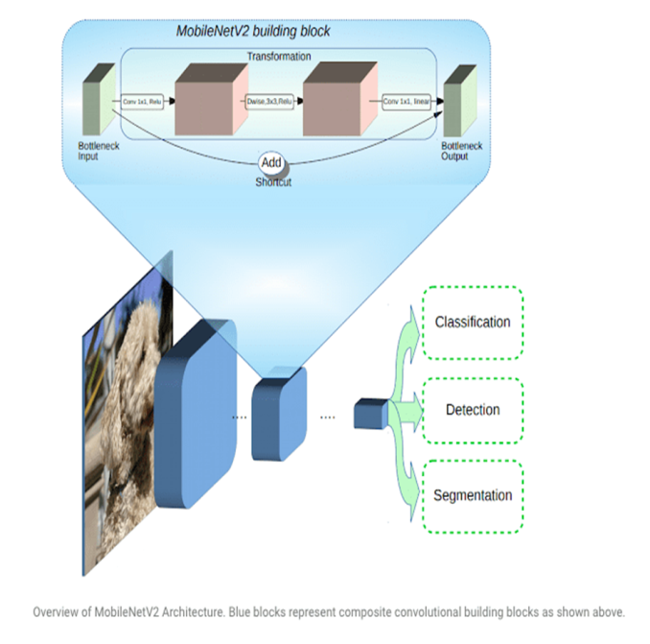

Figure 1: MobileNetV2 Architecture

The Basic Structure of MobileNetV2 consists of the bottlenecks of the which encode the intermediate inputs and outputs while the inner layer encapsulates the model’s ability to transform from lower-level concepts such as pixels to higher level descriptors such as image categories. With traditional residual connections, shortcuts enable faster training and better accuracy. The basic building block is a bottleneck depth-separable convolution with residuals. The architecture of MobileNetV2 contains the initial fully convolution layer with 32 filters, followed by 19 residual bottleneck layers. The architecture is tailored to different performance points, by using the input image resolution and width multiplier as tunable hyper parameters that can be adjusted depending on desired accuracy or performance trade-offs. MobileNet has several properties that make it suitable for mobile applications and allows very memory-efficient inference and utilises standard operations present in all neural frameworks. Thus MobileNetV2 provides a very efficient mobile-oriented model that can be used as a base for many visual recognition tasks like disease detection in plants.

*iii) TensorFlow Lite*:

TensorFlow Lite is a set of tools to help developers run TensorFlow models on mobile, embedded, and IoT devices. It enables on-device machine learning inference with low latency and a small binary size.

TensorFlow Lite consists of two main components:

•The TensorFlow Lite interpreter: This runs specially optimized models on many different hardware types, including mobile phones, embedded Linux devices, and microcontrollers.

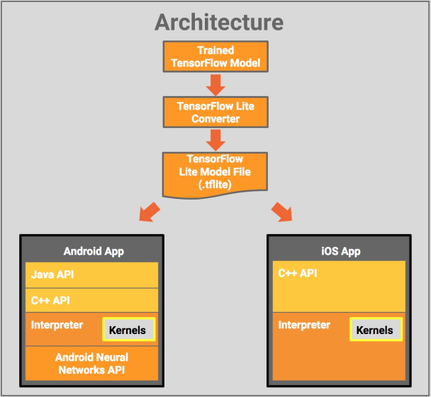

Figure 2: TensorFlow Lite Architecture

•The TensorFlow Lite converter: This converts TensorFlow models into an efficient form for use by the interpreter, and can introduce optimizations to improve binary size and performance.

It is designed to make it easy to perform machine learning on devices, "at the edge" of the network, instead of sending data back and forth from a server. Performing machine learning on-device can help improve latency, privacy, connectivity and power consumption.

**IV. SYSTEM ARCHITECTURE**

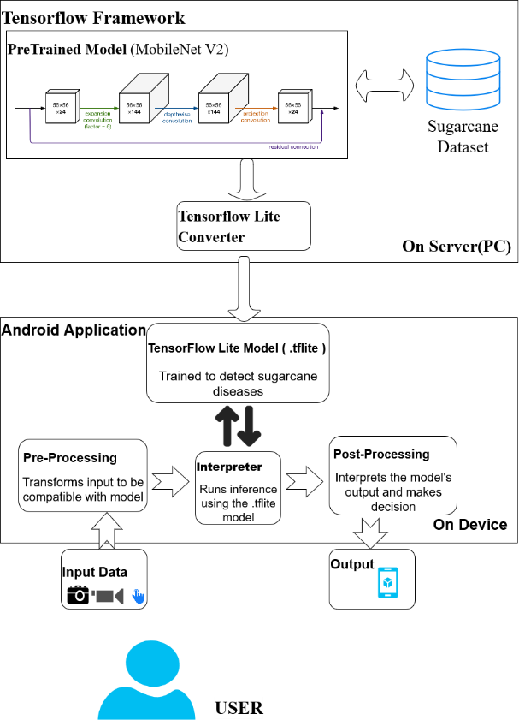

Figure 3: System Architecture

*i) Components of Architecture:*

**USER** - The user here is the client who would be using the android application. The user needs to upload an image of the region to be inspected for diseases in a sugarcane crop. On which the inference will be returned to the user on device.

**Android Application** - It consists of the TensorFlow Lite model which will perform on device inference by invoking the TensorFlow Lite Interpreter. It also pre-processes the input data to be compatible with the .tflite model and post-processes the output result and displays the final Result to the user.

**TensorFlow Framework -** A pre-trained model( here, MobileNet V2) is a saved network that was previously trained on a large dataset, typically on a large-scale image-classification task. This pre-trained model is the base model on which the Sugarcane dataset is trained to obtain a custom model. This is a resource intensive process that occurs in the Server machine and is known as Transfer Learning. The Custom CNN model is saved and converted to .tflite format by TensorFlow Lite Converter.

*ii) Implementation:*

**Image Acquisition:** Appropriate datasets are required at all stages of image recognition research, starting from training phase to evaluating the performance of recognition algorithms. All the images collected for the dataset are manually clicked from the fields. Images in the dataset were grouped into four different classes addressing four major sugarcane diseases: Eye spot, Red rot, White rust and yellow leaf.

**Image Augmentation and Pre-processing:** The main purpose of applying augmentation is to increase the dataset and introduce slight distortion to the images which helps in reducing overfitting during the training stage. The image augmentation can be achieved by several transformation techniques including flipping, rotating etc. Image pre-processing is essential to prepare the dataset to be in a interpretable format by the model. Images used for the dataset were image resized to 224 X 224 to standardize the dataset images

**Training the model for disease identification and classification:** Training the deep convolutional neural network for making an image classification model for the dataset. MobileNetV2 architecture is considered a starting point, but modified and adjusted to support our 4 categories of diseases. For the Sugarcane disease classification model, the intermediate layer of MobileNet V2 will be used for feature extraction. A common practice is to use the output of the very last layer before the flatten operation, the so-called "bottleneck layer". The reasoning here is that the following fully-connected layers will be too specialized to the task the network was trained on, and thus the features learned by these layers won't be very useful for a new task. The bottleneck features, however, retain much generality. A classification head is added on top of this base model(MobileNet V2) with 4 layers for classification.

**Deployment of trained model into Android application:** The Trained model which is obtained in form of saved model is not compatible to integrate with Android Application. Hence, TensorflowLite framework is used to convert the saved model into .tflite format which can be deployed into the android Application.

**Identification and Classification of diseased plants with suggested remedies:** In this phase the images to be tested are clicked and uploaded to the application after granting the required permissions to it. The test images are then processed according to the trained model and are classified into a particular category of identified disease which is then returned to the end user through the Application UI. The application is also fed with the information regarding the diseases classified and their remedial measures. Based on the disease classified the application fetches the relevant information from the data fed and returns the suggested remedies to the end user via the application UI

**V. EXPERIMENTAL RESULTS**

*i) Performance of Model Trained* :

The dataset is divided into training and validation sets. Model is trained on the training dataset and performance is measured against the validation set. As depicted in graph below an accuracy of 99.15% is obtained on the validation set and a loss approximately equal to 4.39% is obtained.

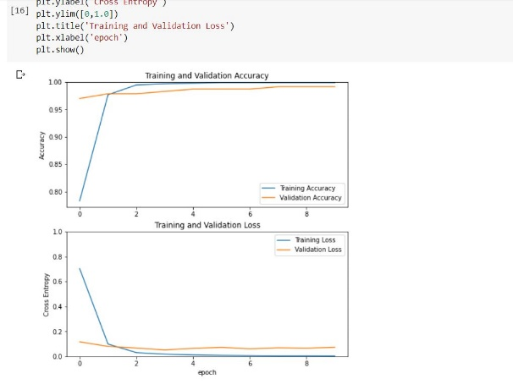

Figure 4: Graph showing Performance accuracy and loss for training and validation datasets.

**VI. CONCLUSIONS**

The problem of early stage disease identification in crops has always been a challenging task to the farmers. The proposed system is an efficient solution to address this issue. It automates the disease detection process by comparing the suspected plant features with the features exhibited by thousands of diseased plants and provides the results to farmers with a high accuracy, thus helping the Farmers to take the preventing measures at the early stage to avoid crop loss. The System is designed to be a user friendly application with an interactive and easy to use UI. The system provides easily accessible solutions as “on device” inference and does not require any internet accessibility to get the solutions .Thus, it can be concluded that the system is an efficient aid to farmers (regardless of the level of experience), enabling fast and efficient recognition of plant diseases and facilitating the decision-making process

**VII. FUTURE WORKS**

This system is used to detect sugarcane diseases using neural networks and perform on device inference. It can be adopted and enhanced by using a larger dataset for disease detection in a wider variety of plants. Also system can be enhanced with features to track the plant growth continuously. And provide customized suggestions to increase crop yield

**REFERENCES**

[1] “Novel Machine Learning Based Approach For Detection And Classification Of Sugarcane Plant Disease By Using DWT”. Suyash S Patil, Sandeep Thorat. CCIP, 2016.

[2] “Detecting Sugarcane Borer Diseases Using Support Vector Machine”. B Sravya Reddy, R Deepa, Shalini, P Bhagya Divya. IJRET Vol.4, 2017.

[3] “Sugarcane Disease Detection Using Data Mining Techniques”. Tien Huang, Rui Yang, Wenshan Huang. Chinese University of Hong-Kong, Elsevier, 2017.

[4] “Paddy Disease Detection System using Image Processing”. S Sathiamoorthy, R Ponnuswamy, M Natarajan. IJRAT, 2018.

[5] “Leaf Disease Detection Using Image Processing”. Radhiah Binti Zainon, 2012.

[6] “Plant Disease Detection Using Different Algorithms”. Sujatha R, Y Shravan Kumar and Garine Uma Akhil. JCHPS Vol.10, 2017.

[7] “An Algorithm for Plant Diseases Detection Based on Color Features”. Trimi Neha Tete, Sushma Kamlu. RICE Vol.10, 2017.

[8] “Real-time Hevea Leaves Diseases Identification using Sobel Edge Algorithm on FPGA: A Preliminary Study”. Moshab Elsghair, Raka Jovanovic, Milan Tuba. IJAS Vol.2, 2017.

[9] “An Investigation Into Machine Learning Regression Techniques for the Leaf Rust Disease Detection Using Hyperspectral Measurement”. Norfarahin Mohd Yusoff, Ilishairah Abdullah. ICGRC, 2018.